Maroon_Response Screen Prints

UW Class Server (Left) Localhost (Right)

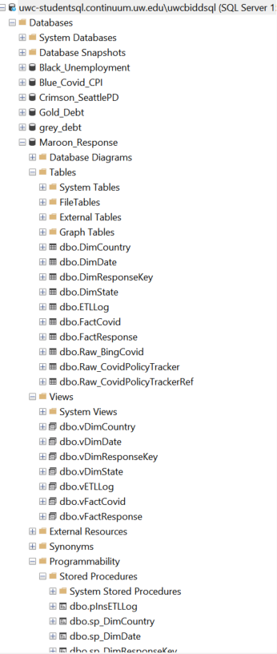

Figure 1: Maroon_Response From UW Class Server

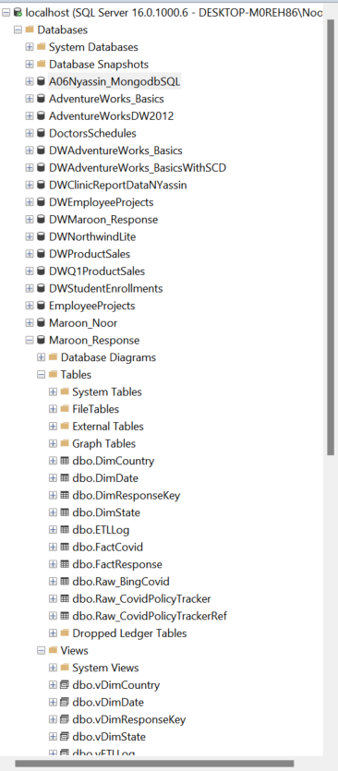

Figure 2: Maroon_Response From Noor Yassin Localhost